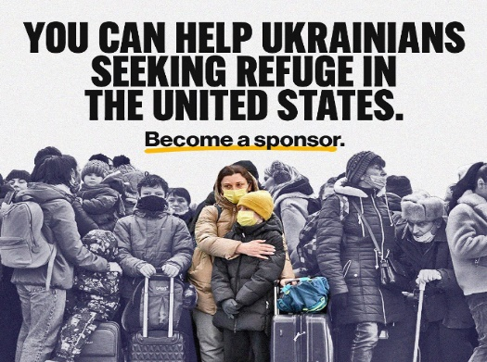

***What is the Uniting For Ukraine Program?***

The war in Ukraine has dragged on for two horrifying, tragic, painful years with no end in sight. The situation is much worse than is being portrayed in the media. Millions have lost their homes, loved ones, livelihoods, hopes and dreams. An entire nation of children has been robbed of their childhood. Millions need a safe place to go until this terrible war is over and rebuilding can begin. Europe is overcrowded with refugees. Many Ukrainian refugees are unable to find housing, jobs and are facing harassment and discrimination in European countries. Some countries such as Spain and Canada have discontinued their programs for Ukrainians. As a result, more and more Ukrainians are seeking safety in the US.

The Uniting For Ukraine program was started in March 2022 by the Biden administration to allow those with legal residency in the US (citizen, green card, work visa, refugee, humanitarian parolee, TPS) to sponsor/host Ukrainians in order to bring them to safety in the US. This is a 2-year temporary program so they can escape the war. It is not currently a path to citizenship.

***What is a beneficiary?***

A beneficiary is the Ukrainian that the sponsor files the I-134a application for. Some beneficiaries have friends or family who are already in the United States and simply need to be sponsored so that they can come live in safety with said friends or family. This is known as paper sponsorship. Some beneficiaries need a sponsor and a host. They don’t yet have a place to live and need housing, financial help of varying degrees and assistance with the resettlement process.

***What is a Sponsor?***

A Sponsor is a legal resident of the US who is willing to complete ~30 minutes of paperwork on behalf of a Ukrainian. It is free to file. The number of beneficiaries that you can file for is based on income. Essentially the Sponsor is asking the government to consider this Ukrainian for the program.

***What is a Host?***

Hosts offer housing to Ukrainian newcomers while they get established in the United States. This is like a foreign exchange student host program. You can meet newcomers at the airport, provide housing, help apply for jobs, enroll children in school, enroll in health insurance, and begin English classes. The host usually also helps the beneficiary apply for a social security number, work authorization and driver’s license when applicable.

***Do I have to be both a Sponsor and a Host?***

No, some people choose to do both, but there are many opportunities to be just a Spo0nsor or a Host. If you only want to do one or the other, you are still very much needed. This will be one of the most rewarding and worthwhile things you will ever do!

***What Does Our Volunteer Group Do And Who Are We?***

We are a grassroots volunteer group who finds sponsors/hosts and matches them with beneficiaries. We are people who wanted to find a way to help Ukrainians find safety and created a group on Facebook for this purpose (we are working on a website). We currently have ~45,000 members in our Facebook group. Unfortunately, about 90% of the members are Ukrainians seeking sponsors. We desperately need sponsors and hosts!

***What Is Our Process?***

1) We screen potential beneficiaries to determine their eligibility for the program and their individual needs. Do they need a sponsor, a host or both? How much financial support do they need? We also determine their level of English, job skills, financial resources, health care needs, and motivation to succeed in the US.

2) If they only need paper sponsorship (they already have a host here) we verify their hosting and support situation. We contact the family member or friend in the US to verify that the beneficiaries really have a place to live for a realistic period of time, financial support, and help with resettlement. We obtain a letter of support from the host to be uploaded with the application.

3) If they also need a host, we try to find a suitable host based on their needs.

4) When we feel we have a good match, we introduce the sponsor/host and beneficiary. If all parties are in agreement, the sponsor gathers the needed documents. (needed documents vary depending on if the sponsor is employed, retired or self-employed)

* A letter from their employer stating position, date of hire, income and if it is a temporary or permanent position.
* most recent pay stub and/or W2 or 1099
* most recent tax return
* most recent bank statement
* proof of US residency status (passport, birth certificate, work visa, I94)

Even though a paper sponsor does not provide housing or financial support, the government still requires this information since there is only one form that is for both traditional and paper sponsorship.

5) The sponsor creates an account at [www.USCIS.gov](http://www.USCIS.gov).

6) The sponsor fills out and submits the I-134a application on this website.

7) Once the application is submitted, the USCIS reviews the application and approves or denies it. Application processing is currently taking around 30 to 90 days.

8) If the sponsor is approved, the beneficiary will receive an email from the USCIS with instructions to create their own account and submit their application for Travel Authorization. Once approved, the beneficiary will receive their travel documents and is now able to enter the US within 90 days.

9) We celebrate!! Congratulations! You have potentially saved lives, future generations, and helped preserve Ukrainian culture and language.

**https://www.facebook.com/groups/uniting4ukraine**